Partner: Darryl Derico

Video Link: <https://www.youtube.com/watch?v=HAaFMS9DRKM>

Code Editor/Compiler: Code Composer Studio  
Serial Connection: PuTTy, Tera Term  
Software: VM Virtual Box, Ubuntu

Final Setup  
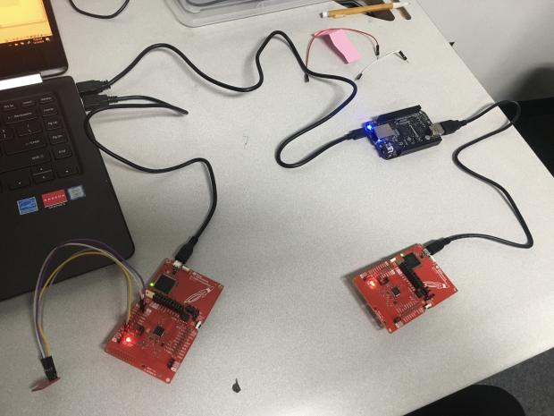

Final Result  
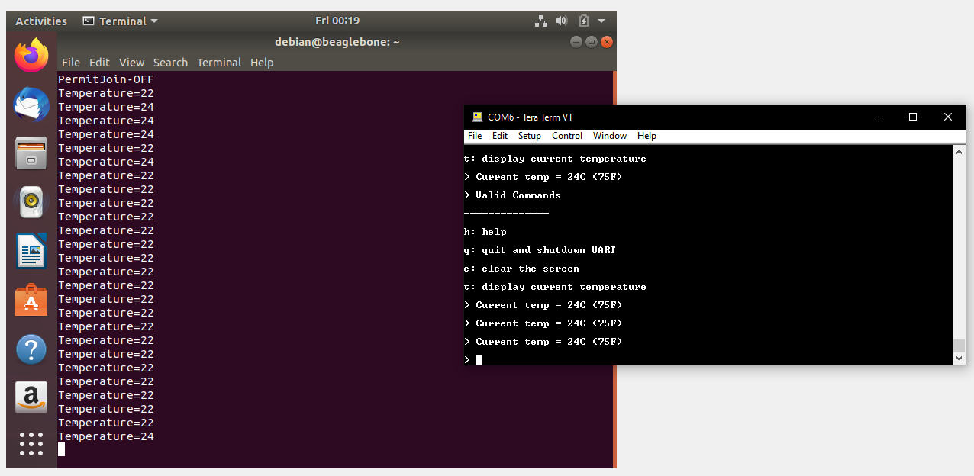

Code:

/*

* ======== console.c ========

*/

#include <stdint.h>

#include <string.h>

#include <stdbool.h>

/* POSIX Header files */

#include <pthread.h>

#include <semaphore.h>

/* Driver Header files */

#include "smsgs.h"

#include "mac_util.h"

#include "api_mac.h"

#include "sensor.h"

extern Smsgs_tempSensorField_t tempSensor;

#include <ti/drivers/GPIO.h>

#include <ti/drivers/UART.h>

#ifdef CC32XX

#include <ti/drivers/Power.h>

#include <ti/drivers/power/PowerCC32XX.h>

#endif

/* Example/Board Header files */

#include "Board.h"

/* Console display strings */

const char consoleDisplay[] = "\fConsole (h for help)\r\n";

const char helpPrompt[] = "Valid Commands\r\n" \

"--------------\r\n" \

"h: help\r\n" \

"q: quit and shutdown UART\r\n" \

"c: clear the screen\r\n" \

"t: display current temperature\r\n";

const char byeDisplay[] = "Bye! Hit button1 to start UART again\r\n";

const char tempStartDisplay[] = "Current temp = ";

const char tempMidDisplay[] = "C (";

const char tempEndDisplay[] = "F)\r\n";

const char cleanDisplay[] = "\f";

const char userPrompt[] = "> ";

const char readErrDisplay[] = "Problem read UART.\r\n";

/* Used to determine whether to have the thread block */

volatile bool uartEnabled = true;

sem_t semConsole;

/* Temperature written by the temperature thread and read by console thread */

extern volatile float temperature;

extern volatile float temperaturef;

/* Mutex to protect the reading/writing of the float temperature */

extern pthread_mutex_t temperatureMutex;

/* Used itoa instead of sprintf to help minimize the size of the stack */

static void itoa(int n, char s[]);

/*

* ======== gpioButtonFxn ========

* Callback function for the GPIO interrupt on Board_GPIO_BUTTON1.

* There is no debounce logic here since we are just looking for

* a button push. The uartEnabled variable protects use against any

* additional interrupts cased by the bouncing of the button.

*/

void gpioButtonFxn(uint_least8_t index)

{

/* If disabled, enable and post the semaphore */

if (uartEnabled == false) {

uartEnabled = true;

sem_post(&semConsole);

}

}

/*

* ======== simpleConsole ========

* Handle the user input. Currently this console does not handle

* user back-spaces or other "hard" characters.

*/

void simpleConsole(UART_Handle uart)

{

char cmd;

int status;

char tempStr[8];

int localTemperatureC;

int localTemperatureF;

UART_write(uart, consoleDisplay, sizeof(consoleDisplay));

/* Loop until read fails or user quits */

while (1) {

UART_write(uart, userPrompt, sizeof(userPrompt));

status = UART_read(uart, &cmd, sizeof(cmd));

if (status == 0) {

UART_write(uart, readErrDisplay, sizeof(readErrDisplay));

cmd = 'q';

}

switch (cmd) {

case 't':

tempSensor.objectTemp = localTemperatureC;

tempSensor.ambienceTemp = localTemperatureC;

Util_setEvent(&Sensor_events, EXT_SENSOR_READING_TIMEOUT_EVT);

UART_write(uart, tempStartDisplay, sizeof(tempStartDisplay));

/*

* Make sure we are accessing the global float temperature variables

* in a thread-safe manner.

*/

pthread_mutex_lock(&temperatureMutex);

localTemperatureC = (int)temperature;

localTemperatureF = (int)temperaturef;

pthread_mutex_unlock(&temperatureMutex);

itoa((int)localTemperatureC, tempStr);

UART_write(uart, tempStr, strlen(tempStr));

UART_write(uart, tempMidDisplay, sizeof(tempMidDisplay));

itoa((int)localTemperatureF, tempStr);

UART_write(uart, tempStr, strlen(tempStr));

UART_write(uart, tempEndDisplay, sizeof(tempEndDisplay));

break;

case 'c':

UART_write(uart, cleanDisplay, sizeof(cleanDisplay));

break;

case 'q':

UART_write(uart, byeDisplay, sizeof(byeDisplay));

return;

case 'h':

default:

UART_write(uart, helpPrompt, sizeof(helpPrompt));

break;

}

}

}

/*

* ======== consoleThread ========

*/

void *consoleThread(void *arg0)

{

UART_Params uartParams;

UART_Handle uart;

int retc;

#ifdef CC32XX

/*

* The CC3220 examples by default do not have power management enabled.

* This allows a better debug experience. With the power management

* enabled, if the device goes into a low power mode the emulation

* session is lost.

* Let's enable it and also configure the button to wake us up.

*/

PowerCC32XX_Wakeup wakeup;

PowerCC32XX_getWakeup(&wakeup);

wakeup.wakeupGPIOFxnLPDS = gpioButtonFxn;

PowerCC32XX_configureWakeup(&wakeup);

Power_enablePolicy();

#endif

/* Configure the button pin */

GPIO_setConfig(Board_GPIO_BUTTON1, GPIO_CFG_IN_PU | GPIO_CFG_IN_INT_FALLING);

/* install Button callback and enable it */

GPIO_setCallback(Board_GPIO_BUTTON1, gpioButtonFxn);

GPIO_enableInt(Board_GPIO_BUTTON1);

retc = sem_init(&semConsole, 0, 0);

if (retc == -1) {

while (1);

}

UART_init();

/*

* Initialize the UART parameters outside the loop. Let's keep

* most of the defaults (e.g. baudrate = 115200) and only change the

* following.

*/

UART_Params_init(&uartParams);

uartParams.writeDataMode = UART_DATA_BINARY;

uartParams.readDataMode = UART_DATA_BINARY;

uartParams.readReturnMode = UART_RETURN_FULL;

/* Loop forever to start the console */

while (1) {

if (uartEnabled == false) {

retc = sem_wait(&semConsole);

if (retc == -1) {

while (1);

}

}

/* Create a UART for the console */

uart = UART_open(Board_UART0, &uartParams);

if (uart == NULL) {

while (1);

}

simpleConsole(uart);

/*

* Since we returned from the console, we need to close the UART.

* The Power Manager will go into a lower power mode when the UART

* is closed.

*/

UART_close(uart);

uartEnabled = false;

}

}

/*

* The following function is from good old K & R.

*/

static void reverse(char s[])

{

int i, j;

char c;

for (i = 0, j = strlen(s)-1; i<j; i++, j--) {

c = s[i];

s[i] = s[j];

s[j] = c;

}

}

/*

* The following function is from good old K & R.

*/

static void itoa(int n, char s[])

{

int i, sign;

if ((sign = n) < 0) /* record sign */

n = -n; /* make n positive */

i = 0;

do { /* generate digits in reverse order */

s[i++] = n % 10 + '0'; /* get next digit */

} while ((n /= 10) > 0); /* delete it */

if (sign < 0)

s[i++] = '-';

s[i] = '\0';

reverse(s);

}

/*

* ======== temperature.c ========

*/

#include <stdint.h>

#include <stddef.h>

#include <unistd.h>

#include <ti/display/Display.h>

/* POSIX Header files */

#include <pthread.h>

#include <semaphore.h>

#include <signal.h>

#include <time.h>

/* Driver Header files */

#include <ti/drivers/GPIO.h>

#include <ti/drivers/I2C.h>

/* Example/Board Header files */

#include "Board.h"

/* ======== Si7021 Registers ======== */

#define Si7021_TMP_REG 0xE3

#define Si7021_HUM_REG 0xE5

#define Si7021_ADDR 0x40

/*

* ======== HIGH_TEMP ========

* Send alert when this temperature (in Celsius) is exceeded

*/

#define HIGH_TEMP 30

/*

* ======== TMP Registers ========

*/

#define TMP006_REG 0x0001 /* Die Temp Result Register for TMP006 */

#define TMP116_REG 0x0000 /* Die Temp Result Register for TMP116 */

/*

* The CC32XX LaunchPads come with an on-board TMP006 or TMP116 temperature

* sensor depending on the revision. Newer revisions come with the TMP116.

* The Build Automation Sensors (BOOSTXL-BASSENSORS) BoosterPack

* contains a TMP116.

*

* We are using the DIE temperature because it's cool!

*

* Additionally: no calibration is being done on the TMPxxx device to simplify

* the example code.

*/

#define TMP006_ADDR 0x41;

#define TMP116_BP_ADDR 0x48;

#define TMP116_LP_ADDR 0x49;

/* Temperature written by the temperature thread and read by console thread */

volatile float temperatureC;

volatile float temperatureF;

volatile float temperaturef;

volatile float temperature;

volatile float temp;

volatile float sample;

Display_Handle display;

/* Mutex to protect the reading/writing of the temperature variables */

extern pthread_mutex_t temperatureMutex;

/*

* ======== clearAlert ========

* Clear the LED

*/

//static void clearAlert(float temperature)

//{

// GPIO_write(Board_GPIO_LED0, Board_GPIO_LED_OFF);

//}

/*

* ======== sendAlert ========

* Okay, just light a LED in this example, but with the SimpleLink SDK,

* you could send it out over the radio to something cool!

*/

//static void sendAlert(float temperature)

//{

// GPIO_write(Board_GPIO_LED0, Board_GPIO_LED_ON);

//}

/*

* ======== postSem ========

* Function called when the timer (created in setupTimer) expires.

*/

static void postSem(union sigval val)

{

sem_t *sem = (sem_t*)(val.sival_ptr);

sem_post(sem);

}

/*

* ======== setupTimer ========

* Create a timer that will expire at the period specified by the

* time arguments. When the timer expires, the passed in semaphore

* will be posted by the postSem function.

*

* A non-zero return indicates a failure.

*/

int setupTimer(sem_t *sem, timer_t *timerid, time_t sec, long nsec)

{

struct sigevent sev;

struct itimerspec its;

int retc;

retc = sem_init(sem, 0, 0);

if (retc != 0) {

return(retc);

}

/* Create the timer that wakes up the thread that will pend on the sem. */

sev.sigev_notify = SIGEV_SIGNAL;

sev.sigev_value.sival_ptr = sem;

sev.sigev_notify_function = &postSem;

sev.sigev_notify_attributes = NULL;

retc = timer_create(CLOCK_MONOTONIC, &sev, timerid);

if (retc != 0) {

return(retc);

}

/* Set the timer to go off at the specified period */

its.it_interval.tv_sec = sec;

its.it_interval.tv_nsec = nsec;

its.it_value.tv_sec = sec;

its.it_value.tv_nsec = nsec;

retc = timer_settime(*timerid, 0, &its, NULL);

if (retc != 0) {

timer_delete(*timerid);

return(retc);

}

return(0);

}

/*

* ======== temperatureThread ========

* This thread reads the temperature every second via I2C and sends an

* alert if it goes above HIGH_TEMP.

*/

void *temperatureThread(void *arg0)

{

uint8_t txBuffer[1];

uint8_t rxBuffer[2];

I2C_Handle i2c;

I2C_Params i2cParams;

I2C_Transaction i2cTransaction;

sem_t semTimer;

// timer_t timerid;

// int retc;

/* Configure the LED and if applicable, the TMP116_EN pin */

GPIO_setConfig(Board_GPIO_LED0, GPIO_CFG_OUT_STD | GPIO_CFG_OUT_LOW);

#ifdef Board_GPIO_TMP116_EN

GPIO_setConfig(Board_GPIO_TMP116_EN, GPIO_CFG_OUT_STD | GPIO_CFG_OUT_HIGH);

/* 1.5 ms reset time for the TMP116 */

sleep(1);

#endif

/*

* Create/Open the I2C that talks to the TMP sensor

*/

I2C_init();

Display_init();

I2C_Params_init(&i2cParams);

i2cParams.bitRate = I2C_400kHz;

i2c = I2C_open(Board_I2C_TMP, &i2cParams);

if (i2c == NULL) {

while (1);

}

/* Common I2C transaction setup */

i2cTransaction.writeBuf = txBuffer;

i2cTransaction.writeCount = 1;

i2cTransaction.readBuf = rxBuffer;

i2cTransaction.readCount = 2;

/*

* Determine which I2C sensor is present.

* We will prefer sensors in this order: TMP116 (on BoosterPacks),

* TMP116 (on-board CC32XX LaunchPads), and last TMP006

* (on older CC32XX LaunchPads).

*/

/*

// Try TMP116 values

txBuffer[0] = TMP116_REG;

i2cTransaction.slaveAddress = TMP116_BP_ADDR;

if (!I2C_transfer(i2c, &i2cTransaction)) {

// Not BP TMP116, try LP TMP116

i2cTransaction.slaveAddress = TMP116_LP_ADDR;

if (!I2C_transfer(i2c, &i2cTransaction)) {

// Not a TMP116 try TMP006

txBuffer[0] = TMP006_REG;

i2cTransaction.slaveAddress = TMP006_ADDR;

if (!I2C_transfer(i2c, &i2cTransaction)) {

// Could not resolve a sensor, error

while(1);

}

}

}

*/

// Try Si7021

txBuffer[0] = Si7021_TMP_REG;

i2cTransaction.slaveAddress = Si7021_ADDR;

if (!I2C_transfer(i2c, &i2cTransaction))

{

// Could not resolve a sensor, error

Display_printf(display, 0, 0, "Error. No TMP sensor found!");

while(1);

}

else

{

Display_printf(display, 0, 0, "Detected Si7021 sensor.");

}

// Take 20 samples and print them out onto the console

for (sample = 0; sample < 100; sample++)

{

if (I2C_transfer(i2c, &i2cTransaction))

{

//

// Extract degrees C from the received data;

// see Si7021 datasheet

//

temp = (rxBuffer[0] << 8) | (rxBuffer[1]);

temperature = (((175.72 * temp)/ 65536) - 46.85); // celsius

temperaturef = (temperature * (1.8)) + 32; //farenheit

Display_printf(display, 0, 0, "Sample %u: %d (C)", sample, temperaturef);

}

else

{

Display_printf(display, 0, 0, "I2C Bus fault.");

}

}

/*

* The temperature thread blocks on the semTimer semaphore, which the

* timerId timer will post every second. The timer is created in the

* setupTimer function. It's returned so the thread could change the

* period or delete it if desired.

*/

// retc = setupTimer(&semTimer, &timerid, 1, 0);

// if (retc != 0) {

// while (1);

// }

// while (1)

// {

// if (I2C_transfer(i2c, &i2cTransaction)) {

// /*

// * Extract degrees C from the received data; see sensor datasheet.

// * Make sure we are updating the global temperature variables

// * in a thread-safe manner.

// */

// pthread_mutex_lock(&temperatureMutex);

// temperatureC = (rxBuffer[0] << 6) | (rxBuffer[1] >> 2);

// temperatureC *= 0.03125;

// temperatureF = temperatureC * 9 / 5 + 32;

// pthread_mutex_unlock(&temperatureMutex);

//

// /* Send an alert if the temperature is too high!! */

// if ((int)temperatureC >= HIGH_TEMP) {

// sendAlert(temperatureC);

// }

// else {

// clearAlert(temperatureC);

// }

// }

//---------------------------------------------------------------------------

/*

// Common I2C transaction setup

i2cTransaction.writeBuf = txBuffer;

i2cTransaction.writeCount = 1;

i2cTransaction.readBuf = rxBuffer;

i2cTransaction.readCount = 2;

*/

/*

// Try Si7021

txBuffer[0] = Si7021_TMP_REG;

i2cTransaction.slaveAddress = Si7021_ADDR;

if (!I2C_transfer(i2c, &i2cTransaction))

{

// Could not resolve a sensor, error

Display_printf(display, 0, 0, "Error. No TMP sensor found!");

while(1);

}

else

{

Display_printf(display, 0, 0, "Detected Si7021 sensor.");

}

// Take 20 samples and print them out onto the console

for (sample = 0; sample < 20; sample++)

{

if (I2C_transfer(i2c, &i2cTransaction))

{

//

// Extract degrees C from the received data;

// see Si7021 datasheet

//

temperature = (rxBuffer[0] << 8) | (rxBuffer[1]);

temperaturef = (((175.72 * temperature)/ 65536) - 46.85);

Display_printf(display, 0, 0, "Sample %u: %d (C)", sample, temperaturef);

}

else

{

Display_printf(display, 0, 0, "I2C Bus fault.");

}

}

*/

//---------------------------------------------------------------------------

// /* Block until the timer posts the semaphore. */

// retc = sem_wait(&semTimer);

// if (retc == -1) {

// while (1);

// }

// }

}

/*

* ======== main_tirtos.c ========

*/

#include <stdint.h>

/* POSIX Header files */

#include <pthread.h>

/* RTOS header files */

#include <ti/sysbios/BIOS.h>

/* Driver header files */

#include <ti/drivers/GPIO.h>

/* Example/Board Header files */

#include <ti/drivers/Board.h>

/* Mutex to protect the reading/writing of the temperature variables */

pthread_mutex_t temperatureMutex;

extern void *temperatureThread(void *arg0);

extern void *consoleThread(void *arg0);

/* Stack size in bytes. Large enough in case debug kernel is used. */

#define THREADSTACKSIZE 1024

/*

* ======== main ========

*/

int main_app(void)

{

pthread_t thread;

pthread_attr_t attrs;

struct sched_param priParam;

int retc;

/* Call driver init functions */

//Board_init();

/* Initialize the attributes structure with default values */

pthread_attr_init(&attrs);

/* Set priority, detach state, and stack size attributes */

priParam.sched_priority = 1;

retc = pthread_attr_setschedparam(&attrs, &priParam);

retc |= pthread_attr_setdetachstate(&attrs, PTHREAD_CREATE_DETACHED);

retc |= pthread_attr_setstacksize(&attrs, THREADSTACKSIZE);

if (retc != 0) {

/* failed to set attributes */

while (1) {}

}

retc = pthread_create(&thread, &attrs, consoleThread, NULL);

if (retc != 0) {

/* pthread_create() failed */

while (1) {}

}

/*

* Let's make the temperature thread a higher priority .

* Higher number means higher priority in TI-RTOS.

*/

priParam.sched_priority = 2;

retc = pthread_attr_setschedparam(&attrs, &priParam);

if (retc != 0) {

/* failed to set priority */

while (1) {}

}

retc = pthread_create(&thread, &attrs, temperatureThread, NULL);

if (retc != 0) {

/* pthread_create() failed */

while (1) {}

}

/* Create a mutex that will protect temperature variables */

retc = pthread_mutex_init(&temperatureMutex, NULL);

if (retc != 0) {

/* pthread_mutex_init() failed */

while (1) {}

}

/* Initialize the GPIO since multiple threads are using it */

//GPIO_init();

/* Start the TI-RTOS scheduler */

//BIOS_start();

return (0);

}